# Exercise 10

Following is the SIMULINK model of the QUBE Servo 2.0 DC motor.

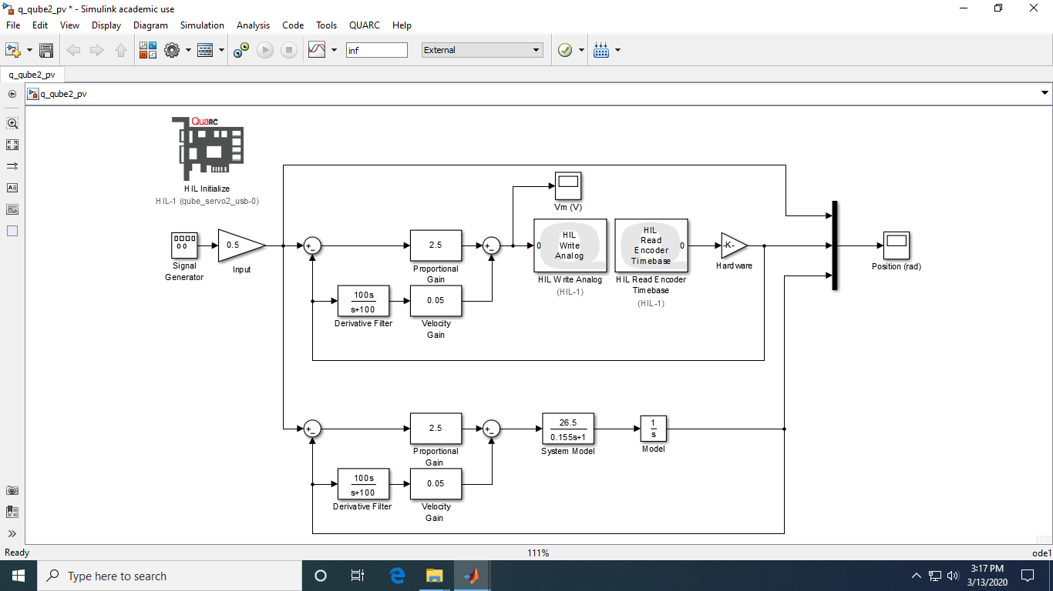

Figure . SIMULINK model

Following is the multiplexed (combined) plot of the input signal, output of the derived model and real time output of the QUBE Servo 2.0 DC motor.

A step input of unit amplitude (A = 1) and frequency of 0.4 Hertz (f = 0.4 Hz) was applied to the system model as well as to the real hardware (QUBE Servo 2.0 DC motor hardware) and the output from both was multiplexed and fed to a scope in SIMULINK.

The output as displayed in the scope is shown in the following figure indicating the input applied to the first principles model and real system as well as the output of (observed from) the model and the real system.

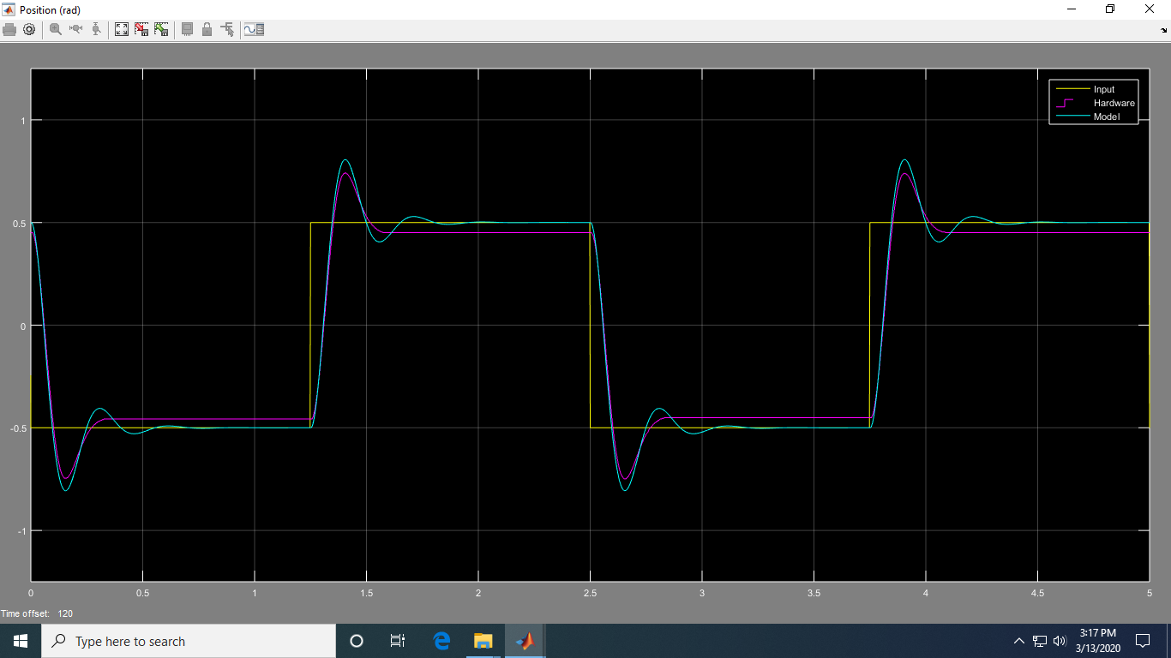

Figure 2. Output

In the above figure, the yellow colour plot is the input, cyan colour plot is the output of the first principles model whereas the purple coloured plot is the real-time output of the QUBE Servo 2.0 DC motor hardware.

Since measurement (sensor – encoder in this case) of physical systems always involves noise/disturbances, a low pass filter (LPF) was introduced so as to minimize the high frequency noise and increase the signal to noise ratio.

It can be seen that the system overshot a little bit (~2.5%) at ~0.15s each time as a result of high gain of P-regulator and then the oscillations were damped out by the D-regulator.

The P and D gains were altered in order to observe their effect on the system response:

* **Keep the derivative gain at 0 and vary kp between 1 and 4:**
* At very low values of kp, the system couldn’t achieve the prescribed setpoint since the (error*kp) value was too small.
* At a critical value of kp, the system achieved the setpoint without any overshoot.
* Beyond the critical value, the system would overshoot since the (error*kp) value was larger than what was required.
* **Set kp from calculation and vary the derivative gain kd between 0 and 0.15:**
* At very low values of kd, the system kept oscillating since the gain was not sufficient to damp the oscillations (under damped system).
* At a critical value of kd, the oscillations were damped out totally (critically damped system).
* Beyond the critical value, the system couldn’t reach the prescribed specifications (overdamped system).